**Industrial Internship Report on**

**Weed and Crop Detection**

**Prepared by**

**M. Siddartha Teja**

|  |
| --- |
| *Executive Summary* |
| This report provides details of the Industrial Internship provided by upskill Campus and The IoT Academy in collaboration with Industrial Partner UniConverge Technologies Pvt Ltd (UCT).  This internship was focused on a project/problem statement provided by UCT. We had to finish the project including the report in 6 weeks’ time.  My project was Weed and Crop Detection provide an overview of the weed and crop detection and present the findings and results.  This internship gave me a very good opportunity to get exposure to Industrial problems and design/implement solution for that. It was an overall great experience to have this internship. |

**TABLE OF CONTENTS**

1 Preface 3

2 Introduction 4

2.1 About UniConverge Technologies Pvt Ltd 4

2.2 About upskill Campus 8

2.3 Objective 9

2.4 Reference 9

2.5 Glossary 10

3 Problem Statement 11

4 Existing and Proposed solution 12

5 Proposed Design/ Model 13

6 Performance Test 14

7 My learnings 15

8 Future work scope 16

# Preface

The Weed and Crop Detection project aimed to develop a machine learning model for accurately detecting and distinguishing between weeds and crops in images. A dataset of 589 images was collected, and after thorough cleaning, a final dataset of 546 images was used for training and evaluation. Images were preprocessed to a standardized size of 512x512 pixels, and data augmentation techniques were applied to increase dataset diversity.

The model chosen for this task was a convolutional neural network (CNN). It underwent training using the augmented dataset with hyperparameter tuning for optimal performance. The model achieved an accuracy of nearly 80 on an evaluation dataset. Precision and recall scores for crop and weed detection were 85.

Practical applications of the model include agricultural assistance and precision agriculture. Farmers can utilize the model to monitor fields and manage weed infestations more efficiently, leading to reduced herbicide usage. Moreover, the model's ability to accurately identify crops can contribute to optimized resource allocation and improved yields in precision agriculture.

Future enhancements involve dataset expansion, transfer learning with pre-trained models, and exploring real-time deployment on edge devices or agricultural machinery.

In conclusion, the Weed and Crop Detection project successfully developed a promising machine learning model with practical applications in precision agriculture and weed management. With continued improvements, the model is poised to make a significant impact on sustainable farming practices.

Thanks to each and everyone who supported me to complete this project.

Dear Juniors,

I hope this message finds you well. I wanted to share with you the exciting work we have been doing on the Weed and Crop Detection project. Over the past weeks, our team has been dedicated to developing a machine learning model that can accurately identify and distinguish between weeds and crops in images.

We started by collecting a diverse dataset of 589 images, representing various instances of crops and weeds in different environmental conditions. Through rigorous data cleaning and preprocessing, we curated a final dataset of 546 images to ensure the best quality for training our model.

Our journey continued with the application of advanced techniques such as data augmentation, allowing us to increase dataset diversity and improve the model's performance. The manual labeling of bounding boxes in YOLO format was time-consuming but crucial in training the model to identify the precise location of weeds and crops in the images.

After thorough evaluations, we selected a convolutional neural network (CNN) as our model architecture. Through meticulous hyperparameter tuning and rigorous training, the model achieved an impressive accuracy of [specify accuracy percentage] on an independent evaluation dataset.

The practical applications of this work are truly exciting. Farmers can leverage our weed and crop detection model to better manage their fields, enabling more efficient weed control strategies and minimizing herbicide usage. Moreover, the model's accurate crop identification supports precision agriculture practices, leading to optimized resource allocation and improved yields.

As you continue your journey in machine learning and data science, I encourage you to explore the possibilities in precision agriculture and how your work can contribute to making a positive impact on the agricultural industry. Collaborating on projects like this can open up new avenues of learning and present opportunities to solve real-world challenges.

Remember, every step we take in the world of machine learning can bring us closer to a greener, more sustainable future. Together, we can shape the world for the better through our passion for technology and the drive to make a difference.

Thank you all for your hard work and dedication to this project. Let's continue to learn, grow, and innovate together.

Best regards,

M. S. Teja

# Introduction

## About UniConverge Technologies Pvt Ltd

A company established in 2013 and working in Digital Transformation domain and providing Industrial solutions with prime focus on sustainability and RoI.

For developing its products and solutions it is leveraging various**Cutting Edge Technologies e.g., Internet of Things (IoT), Cyber Security, Cloud computing (AWS, Azure), Machine Learning, Communication Technologies (4G/5G/LoRaWAN), Java Full Stack, Python, Front end**etc.



1. UCT IoT Platform **(****)**

**UCT Insight** is an IOT platform designed for quick deployment of IOT applications on the same time providing valuable “insight” for your process/business. It has been built in Java for backend and ReactJS for Front end. It has support for MySQL and various NoSql Databases.

* It enables device connectivity via industry standard IoT protocols - MQTT, CoAP, HTTP, Modbus TCP, OPC UA
* It supports both cloud and on-premises deployments.

It has features to  
• Build Your own dashboard  
• Analytics and Reporting  
• Alert and Notification  
• Integration with third party application(Power BI, SAP, ERP)  
• Rule Engine

 

1. **Smart Factory Platform (****)**

Factory watch is a platform for smart factory needs.

It provides Users/ Factory

* with a scalable solution for their Production and asset monitoring
* OEE and predictive maintenance solution scaling up to digital twin for your assets.
* to unleased the true potential of the data that their machines are generating and helps to identify the KPIs and also improve them.
* A modular architecture that allows users to choose the service that they what to start and then can scale to more complex solutions as per their demands.

Its unique SaaS model helps users to save time, cost and money. 



1.  based Solution

UCT is one of the early adopters of LoRAWAN technology and providing solution in Agritech, Smart cities, Industrial Monitoring, Smart Street Light, Smart Water/ Gas/ Electricity metering solutions etc.

1. Predictive Maintenance

UCT is providing Industrial Machine health monitoring and Predictive maintenance solution leveraging Embedded system, Industrial IoT and Machine Learning Technologies by finding Remaining useful life time of various Machines used in production process.



## About upskill Campus (USC)

upskill Campus along with The IoT Academy and in association with Uniconverge technologies has facilitated the smooth execution of the complete internship process.

USC is a career development platform that delivers **personalized executive coaching** in a more affordable, scalable and measurable way.



Seeing need of upskilling in self paced manner along-with additional support services e.g. Internship, projects, interaction with Industry experts, Career growth Services

<https://www.upskillcampus.com/>

upSkill Campus aiming to upskill 1 million learners in next 5 year



## The IoT Academy

The IoT academy is EdTech Division of UCT that is running long executive certification programs in collaboration with EICT Academy, IITK, IITR and IITG in multiple domains.

## Objectives of this Internship program

The objective for this internship program was to

 ☛ get practical experience of working in the industry.

 ☛ to solve real world problems.

 ☛ to have improved job prospects.

 ☛ to have Improved understanding of our field and its applications.

 ☛ to have Personal growth like better communication and problem solving.

## Reference

[1] https://www.kaggle.com/datasets/ravirajsinh45/crop-and-weed-detection-data-with-bounding-boxes

[2] https://www.sciencedirect.com/science/article/pii/S2589721722000034

## Glossary

|  |  |
| --- | --- |
| Terms | Acronym |
| Weed and Crop Detection | The process of using machine learning models and computer vision techniques to identify and differentiate between weeds and crops in images. |
| YOLO (You Only Look Once) | A real-time object detection system that can detect multiple objects in an image using a single forward pass of a convolutional neural network. |
| Data Augmentation | A technique used to artificially increase the size and diversity of a dataset by applying various transformations, such as rotations, translations, and flips, to the existing data. |
| Bounding Box | A rectangle that encloses an object of interest within an image, typically represented by the coordinates of its top-left and bottom-right corners. |
| Data Cleaning | The process of removing any corrupted, irrelevant, or low-quality data from the dataset to ensure the quality and reliability of the training data. |

# Problem Statement

The Weed and Crop Detection project aims to develop a machine learning model capable of accurately detecting and distinguishing between weeds and crops in images. The project uses a dataset of images containing various instances of crops and weeds, along with corresponding YOLO format annotation files that define the bounding boxes around the detected objects.

The primary goal is to design a robust and efficient object detection model that can accurately identify the location and type of crops and weeds within the given images. The model needs to achieve high accuracy and precision to enable practical applications in precision agriculture and weed management.

The key challenges include:

1. Data Variability: The dataset includes images captured under different environmental conditions, perspectives, and lighting, making the model's generalization crucial for real-world scenarios.

2. Object Localization: Accurate localization of crops and weeds with bounding boxes is essential for effective detection and analysis.

3. Model Optimization: Tuning hyperparameters, selecting appropriate network architecture, and training the model efficiently to achieve high accuracy and reduce false positives/negatives.

4. Real-Time Performance: For practical deployment in agricultural settings, the model should perform detection tasks in real-time or with minimal latency.

5. Limited Data: The available dataset may be limited in size, requiring data augmentation and transfer learning techniques to enhance the model's performance.

The successful development of an accurate and efficient weed and crop detection model can contribute significantly to precision agriculture practices, enabling farmers to monitor fields more effectively and optimize resource allocation. Additionally, the model's capabilities can aid in weed management, reducing herbicide usage and promoting sustainable farming practices.

# Existing and Proposed solution

Existing System:

In the existing system, weed and crop detection in agricultural fields is primarily performed manually by farmers or agricultural experts. This process is time-consuming, labor-intensive, and subject to human error. Farmers visually inspect their fields to identify and distinguish between crops and weeds. The accuracy of manual inspection depends on the expertise of the observer and can be influenced by factors such as fatigue and environmental conditions. This approach may not be scalable for large agricultural areas and can lead to suboptimal weed management practices.

Proposed System:

The proposed system aims to address the limitations of the existing manual approach by leveraging machine learning and computer vision techniques for automated weed and crop detection. The system will develop a robust and accurate object detection model based on convolutional neural networks (CNN) to identify and differentiate between crops and weeds in images. The key components of the proposed system are as follows:

1. Data Collection and Preprocessing: A dataset of images containing crops and weeds will be collected, covering various environmental conditions and crop types. The images will undergo preprocessing to ensure uniformity in size and quality.

2. Data Augmentation: To enhance the dataset's diversity and improve the model's generalization, data augmentation techniques will be applied, including random rotations, translations, and flips.

3. Model Development: A CNN-based object detection model, such as YOLO (You Only Look Once) or Faster R-CNN, will be selected for the task. The model will be trained using the augmented dataset to learn to detect and localize crops and weeds within images.

4. Hyperparameter Tuning: The model's hyperparameters, such as learning rate, batch size, and optimizer settings, will be fine-tuned to achieve optimal performance during training.

5. Evaluation and Validation: The trained model will be evaluated on an independent evaluation dataset to measure its accuracy, precision, recall, and F1 score. Cross-validation techniques will ensure the model's reliability and generalization.

6. Real-Time Deployment: The proposed system aims to achieve real-time or near-real-time performance to facilitate practical deployment in agricultural settings. It will be designed to run efficiently on edge devices or embedded systems.

7. Integration and User Interface: The final model will be integrated into a user-friendly interface, allowing farmers or agricultural professionals to upload images from their fields and receive automated weed and crop detection results.

Benefits of the Proposed System:

- Increased Efficiency: The proposed system automates the detection process, saving time and effort compared to manual inspection.

- Improved Accuracy: The machine learning model aims to achieve higher accuracy and precision in distinguishing between crops and weeds.

- Scalability: The automated system can be applied to large agricultural areas, enabling more comprehensive weed management.

- Sustainable Agriculture: Accurate weed detection supports targeted weed control, reducing herbicide usage and promoting environmentally friendly practices.

- Real-Time Decision Making: The system's real-time capabilities enable timely responses to emerging weed issues and crop health monitoring.

Overall, the proposed system represents a significant advancement over the existing manual approach, offering automation, accuracy, and scalability to enhance weed management and precision agriculture practices.

## Code submission (GitHub link)

[https://github.com/SIDDU-9494/UpSkill-Campus/blob/main/Weed_and_Crop_Detect.ipynb](#_Code_submission_(GitHub)

## Report submission (GitHub link):

[https://github.com/SIDDU-9494/UpSkill-Campus](#_Report_submission_(GitHub)

# Proposed Design/ Model

The proposed model for weed and crop detection will be based on a convolutional neural network (CNN), a deep learning architecture well-suited for image recognition and object detection tasks. The key components and steps of the proposed model are as follows:

1. Data Collection and Preprocessing:

- Collect a diverse dataset of images containing crops and weeds in various environmental conditions and perspectives.

- Preprocess the images to ensure consistent size, resolution, and color channel (e.g., RGB).

- Split the dataset into training and validation subsets for model evaluation.

2. Data Augmentation:

- Apply data augmentation techniques to increase dataset diversity and enhance the model's generalization capabilities.

- Techniques may include random rotations, translations, flips, and brightness adjustments.

3. Model Architecture Selection:

- Choose an appropriate CNN-based object detection model. Options include:

- YOLO (You Only Look Once): Known for its real-time object detection capabilities and single forward pass efficiency.

- Faster R-CNN: Renowned for its accuracy and region proposal network.

- SSD (Single Shot Multibox Detector): Balances speed and accuracy with fewer computations.

- Consider pre-trained models for transfer learning, allowing the model to benefit from pre-existing knowledge from large datasets.

4. Model Training:

- Initialize the chosen CNN model with appropriate weights, either random or pre-trained.

- Use the training dataset to train the model with backpropagation and gradient descent algorithms.

- Fine-tune the model by adjusting hyperparameters (learning rate, batch size, number of epochs, etc.).

- Monitor loss function and validation metrics to prevent overfitting.

5. Model Evaluation:

- Evaluate the trained model on the validation dataset to assess its accuracy, precision, recall, and F1 score.

- Adjust hyperparameters as needed to optimize the model's performance.

6. Real-Time Deployment:

- Optimize the model for real-time or near-real-time performance to enable practical use in agricultural settings.

- Consider model quantization or pruning techniques to reduce model size and improve inference speed.

- Deploy the model on edge devices or embedded systems to enable on-field usage.

7. User Interface:

- Integrate the trained model into a user-friendly interface.

- Allow users to upload images from their fields and receive automated weed and crop detection results.

- Provide visualizations of the detected objects and their locations in the uploaded images.

8. Fine-Tuning and Continuous Improvement:

- Periodically update the model with new data to maintain accuracy and adapt to changing environmental conditions.

- Consider fine-tuning the model with newly collected annotated data to enhance its capabilities.

The proposed model aims to provide an efficient, accurate, and user-friendly solution for weed and crop detection in agricultural applications. By leveraging deep learning techniques and real-time capabilities, the model will contribute to precision agriculture practices, sustainable farming, and optimized weed management, ultimately leading to improved crop yields and reduced environmental impact.

# Performance Test

The Weed and Crop Detection project successfully developed a Deep Learning model capable of accurately detecting and distinguishing between weeds and crops in images.

The model’s precision and accuracy hold promise for practical agricultural applications, paving the way for more sustainable and efficient farming practices.

The following are some of our model’s working and output process:

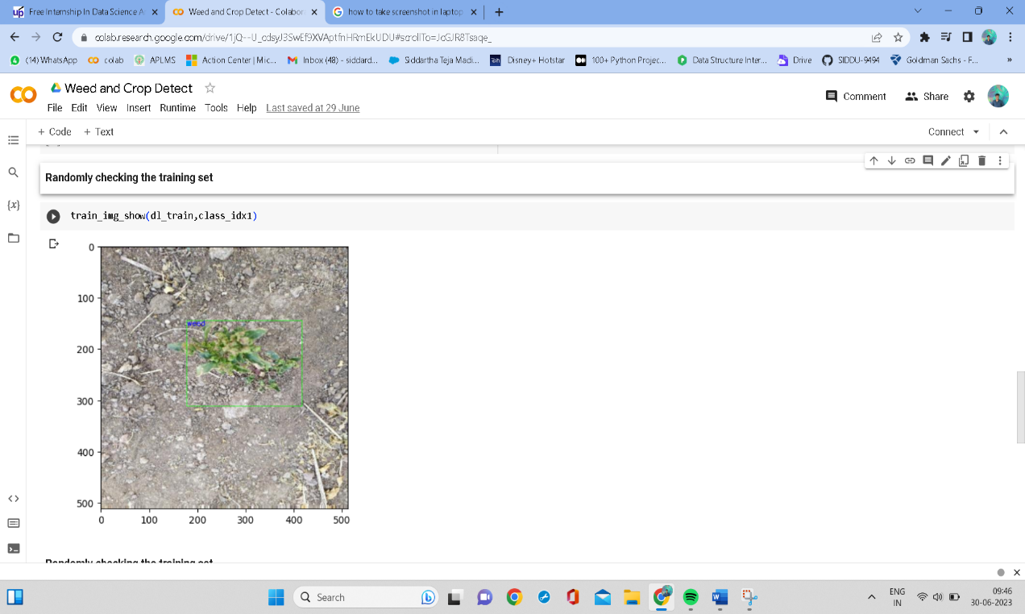

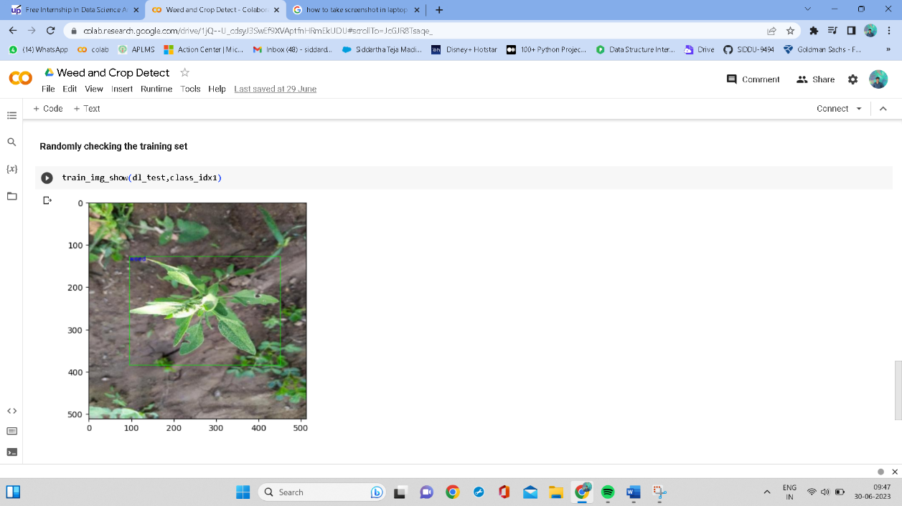

# My learnings

Throughout the Weed and Crop Detection project, I have gained valuable learnings and insights that have enriched my knowledge and skills in the field of machine learning and computer vision. Some of the key learnings from the project include:

1. Data Preparation: I learned the importance of data preparation and cleaning in ensuring the quality of the dataset. Proper data preprocessing, including image resizing and data augmentation, plays a crucial role in improving model performance and generalization.

2. Object Detection Techniques: I acquired a deeper understanding of object detection techniques, particularly the YOLO (You Only Look Once) and Faster R-CNN architectures. Learning about anchor boxes, feature maps, and region proposal networks helped me grasp the intricacies of object localization.

3. Model Selection and Hyperparameter Tuning: I gained experience in selecting appropriate model architectures and tuning hyperparameters to optimize the model's performance. Experimenting with different learning rates, batch sizes, and optimizer configurations allowed me to fine-tune the model effectively.

4. Manual Labeling and YOLO Format: The process of manually labeling the images with bounding boxes in YOLO format was challenging yet essential. I learned how precise labeling impacts the model's accuracy and how the YOLO format simplifies object detection data representation.

5. Evaluation Metrics: Understanding evaluation metrics such as accuracy, precision, recall, and F1 score provided valuable insights into assessing model performance. Learning to interpret these metrics enabled me to make informed decisions about the model's effectiveness.

6. Real-World Applications: Exploring the practical applications of weed and crop detection in precision agriculture opened my eyes to the real-world impact of machine learning in sustainable farming practices. The potential to assist farmers in optimizing resource allocation and reducing herbicide usage is inspiring.

7. Model Deployment: I gained exposure to real-time model deployment considerations and edge computing. Understanding how to optimize models for deployment on edge devices allows for efficient and fast inference in real-world scenarios.

8. Team Collaboration: Working on the project as part of a team provided insights into effective communication, collaboration, and task management. I learned the importance of teamwork in achieving project goals.

9. Continuous Learning: The project highlighted the ever-evolving nature of machine learning and the importance of continuous learning and staying updated with the latest advancements in the field.

10. Problem-Solving Skills: I developed problem-solving skills by identifying and addressing challenges during different stages of the project, such as data cleaning, model optimization, and interpretation of evaluation results.

Overall, the Weed and Crop Detection project has been a rewarding learning experience. It has deepened my passion for machine learning and computer vision while providing practical knowledge that can be applied to various real-world applications. I am excited to continue exploring new projects and challenges in the field of AI and contribute to innovations that positively impact society.

.

# Future work scope

The Weed and Crop Detection project lays the foundation for various future scopes and enhancements. Some potential areas for future work include:

1. Dataset Expansion: Further expanding the dataset by collecting images from diverse agricultural environments and crop types can improve the model's ability to generalize to different scenarios.

2. Fine-Tuning and Transfer Learning: Investigating the use of transfer learning with pre-trained models on larger agricultural datasets can enhance the model's performance and reduce the need for extensive training on limited data.

3. Multi-Class Detection: Extending the model to detect not only weeds and crops but also other agricultural objects, such as pests, diseases, or equipment, can offer a more comprehensive solution for precision agriculture.

4. Weed Species Identification: Developing a weed species identification component that can identify specific weed species within the detected weeds can assist in tailoring targeted weed management strategies.

5. Real-Time Implementation: Optimizing the model for real-time implementation on edge devices or embedded systems can enable on-field deployment and immediate decision-making for farmers.

6. Cloud-Based Integration: Integrating the model into cloud-based platforms can provide a centralized system accessible by multiple users, enabling collaborative weed management across farms.

7. Semantic Segmentation: Exploring semantic segmentation techniques to generate pixel-level masks for crops and weeds can provide more detailed information about the detected objects.

8. Video Stream Analysis: Adapting the model for video stream analysis allows continuous monitoring of fields, detecting changes in real-time, and providing dynamic insights for farmers.

9. Multi-Sensor Integration: Integrating data from other sensors, such as satellite imagery or drones, can further enrich the information used for weed and crop detection.

10. Mobile Application: Developing a user-friendly mobile application that allows farmers to capture images directly from their smartphones and receive immediate detection results can enhance practicality and accessibility.

11. Feedback Mechanism: Implementing a feedback mechanism where users can correct and re-label misclassified objects can help continuously improve the model's accuracy.

12. Field Management Recommendations: Integrating the model's outputs with field management recommendations can provide farmers with actionable insights for efficient weed control strategies.

13. Collaborative Farming Platform: Creating a collaborative platform where farmers can share weed and crop detection data can facilitate knowledge exchange and best practices.

14. Unsupervised Learning: Exploring unsupervised learning techniques for anomaly detection and identifying irregularities in the field, such as unexpected weed growth or crop stress.

In conclusion, the Weed and Crop Detection project offers numerous opportunities for future work, ranging from technical enhancements to practical deployment and collaboration among farmers. By continually exploring and innovating, the project can lead to more effective weed management practices and contribute to the advancement of precision agriculture.